

PICO-APL2 Rev A1.0_0_0

Jumper and Connector Settings

QIG

Released 2022/06/24
Function Block
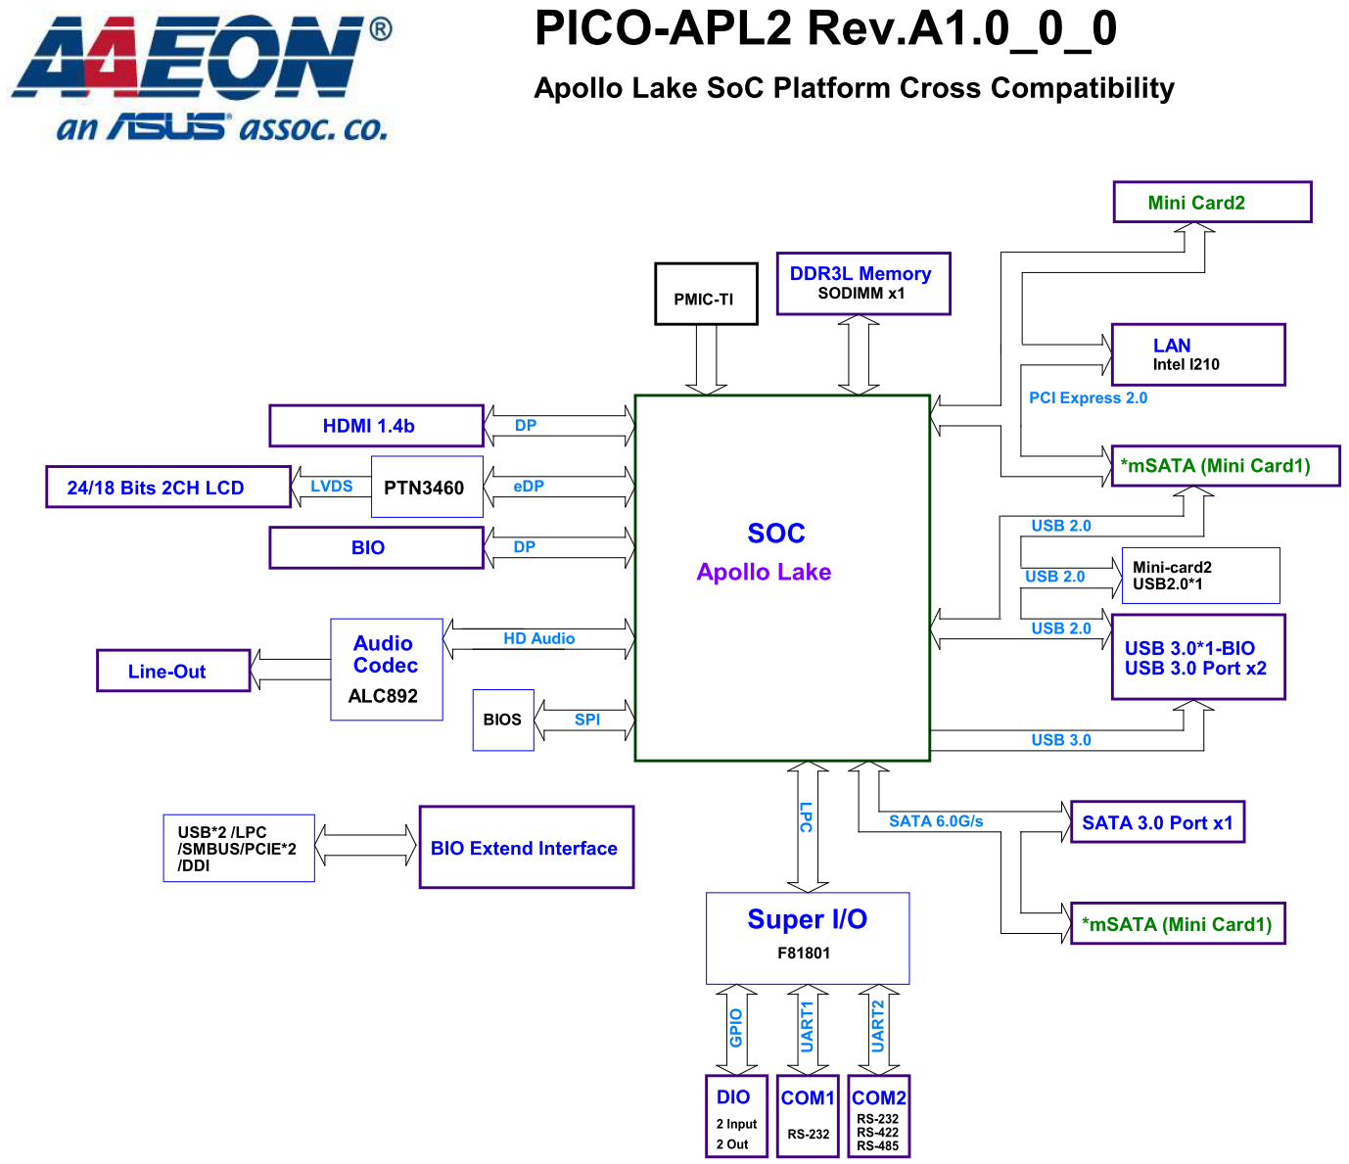
Board Layout:
TOP View:
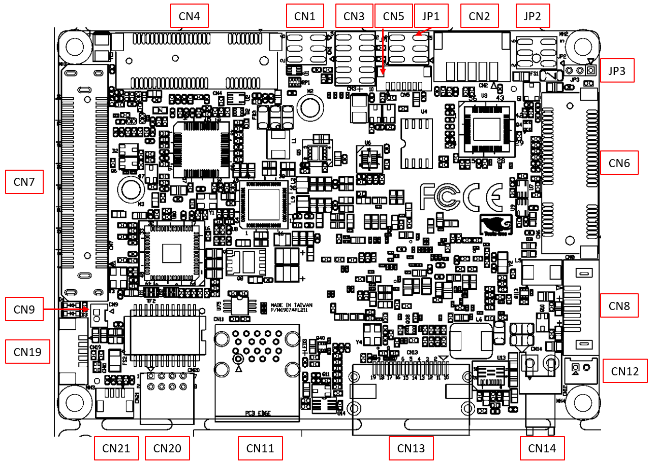
BOT View:
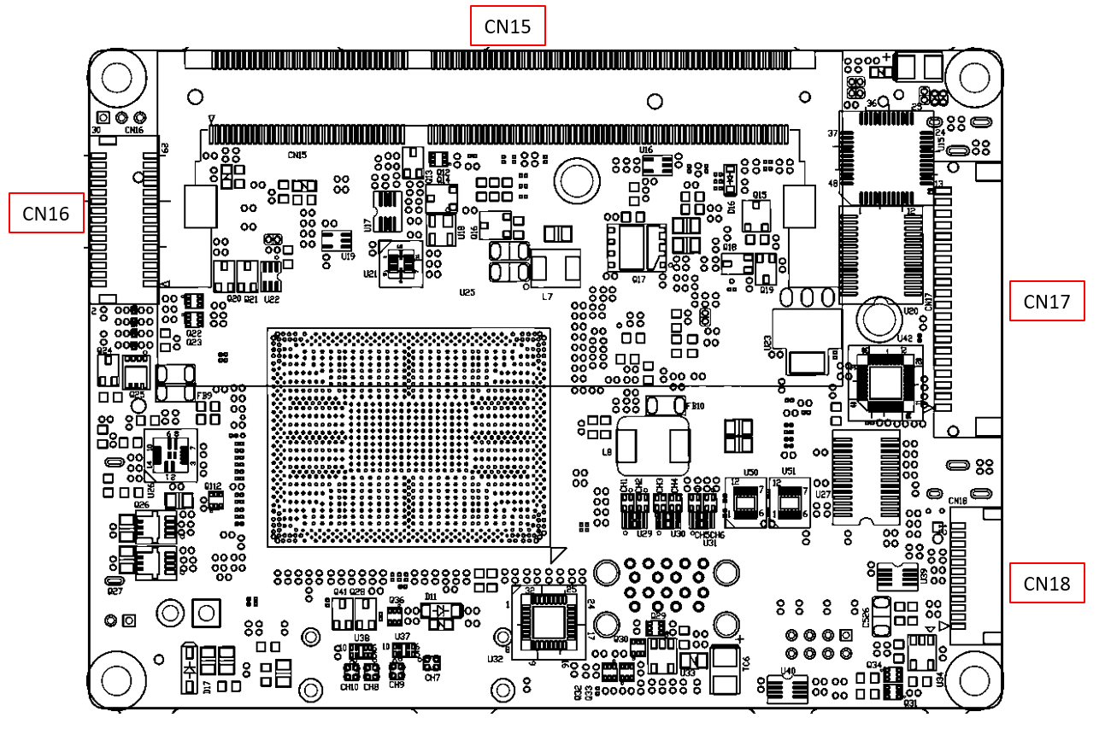
List of Jumpers
Jumpers allow users to manually customize system configurations to their suitable application needs.

The following chart consist the list of each jumper function:

Label | Function
JP1  JP2  JP3 | Clear CMOS Jumper & Auto Power Button Enable/Disable  LVDS Port Operating Voltage Selection &  LVDS Port Backlight Inverter Voltage Selection  LVDS Port Backlight Lightness Control Mode Selection

(JP1) Clear CMOS Jumper & Auto Power Button Enable/Disable
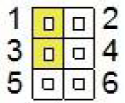
Clear CMOS Jumper
1-3 | Save CMOS | Default
3-5 | Clear CMOS
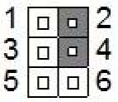
Auto Power Button Enable/Disable
2-4 | Enable | Default
4-6 | Disable

(JP2) LVDS Port Operating Voltage Selection & LVDS Port Backlight Inverter Voltage Selection
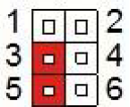
LVDS Port Operating Voltage Selection
1-3 | +5V
3-5 | +3.3V | Default
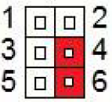
LVDS Port Backlight Inverter Voltage Selection
2-4 | +12V
4-6 | +5V | Default

(JP3) LVDS Port Backlight Lightness Control Mode Selection
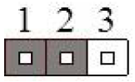
LVDS Port Operating Voltage Selection
1-2 | VR Mode | Default
2-3 | PWM Mode

List of Connectors
Connectors on board access link to external devices such as hard disk drives, a keyboard.
Label | Function
CN1 | Digital IO Port
CN2 | LVDS Port Inverter / Backlight Connector
CN3 | Front Panel
CN4 | Mini Card Slot (Half-Mini Card)
CN5 | SPI Programming Header
CN6 | Mini Card Slot (Full-Size)/mSATA (By BOM)
CN7 | BIO connector
CN8 | SATA Port
CN9 | Battery
CN11 | USB3.2 Gen 1 Port 1, Port 2
CN12 | +5V Output for SATA HDD
CN13 | HDMI Port
CN14 | External +12V Input
CN15 | DDR3L SO-DIMM Slot
CN16 | LVDS Port
CN17 | COM Port 1, Port 2 and Line-Out Connector
CN18 | LPC Port
CN19 | USB2.0 Port 1
CN20 | LAN (RJ-45) Port
CN21 | LAN (RJ-45) LED Port

(CN1) Digital IO Port
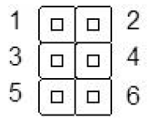
Pin | Pin Name | Signal Type | Signal level
1 | +5V | PWR | +5V
2 | DIO0 | I/O | +5V
3 | DIO1 | I/O | +5V
4 | DIO2 | I/O | +5V
5 | DIO3 | I/O | +5V
6 | GND | GND

(CN2) LVDS Port Inverter / Backlight Connector
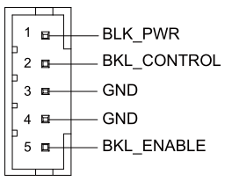
Pin | Pin Name | Signal Type | Signal level
1 | BLK_PWR | PWR | +5V / +12V
2 | BKL_CONTROL | OUT
3 | GND | GND
4 | GND | GND
5 | BKL_ENABLE | OUT | +3.3V
Note1: LVDS/BKL_PWR can be set to +5V or +12V by JP2.
Note2: LVDS/BKL_CONTROL can be set by JP3.
Note3: The driving current supports up to 2A.
(CN3) Front Panel
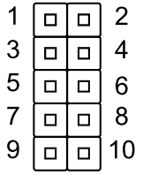
Pin | Pin Name | Pin | Pin Name
1 | PWR_BTN- | 2 | PWR_BTN+
3 | HDD_LED- | 4 | HDD_LED+
5 | BUZZER- | 6 | BUZZER+
7 | PWR_LED- | 8 | PWR_LED+
9 | H/W RESET- | 10 | H/W RESET+

(CN4) Mini Card Slot (Half-Mini Card)
Pin | Pin Name | Signal Type | Signal level
1 | PCIE_WAKE# | IN
2 | +3.3VSB | PWR | +3.3V
3 | NC
4 | GND | GND
5 | NC
6 | +1.5V | PWR | +1.5V
7 | PCIE_CLK_REQ# | IN
8 | NC
9 | GND | GND
10 | NC
11 | PCIE_REF_CLK- | DIFF
12 | NC
13 | PCIE_REF_CLK+ | DIFF
14 | NC
15 | GND | GND
16 | NC
17 | NC
18 | GND | GND
19 | NC
20 | W_DISABLE# | OUT | +3.3V
21 | GND | GND
22 | PCIE_RST# | OUT | +3.3V
23 | PCIE_RX- | DIFF
24 | +3.3VSB | PWR | +3.3V
25 | PCIE_RX+ | DIFF
26 | GND | GND
27 | GND | GND
28 | +1.5V | PWR | +1.5V
29 | GND | GND
30 | SMB_CLK | I/O | +3.3V
31 | PCIE_TX- | DIFF
32 | SMB_DATA | I/O | +3.3V
33 | PCIE_TX+ | DIFF
34 | GND | GND
35 | GND | GND
36 | USB_D- | DIFF
37 | GND | GND
38 | USB_D+ | DIFF
39 | +3.3VSB | PWR | +3.3V
40 | GND | GND
41 | +3.3VSB | PWR | +3.3V
42 | NC
43 | GND | GND
44 | NC
45 | NC
46 | NC
47 | NC
48 | +1.5V | PWR | +1.5V
49 | NC
50 | GND | GND
51 | NC
52 | +3.3VSB | PWR | +3.3V

(CN5) SPI Programming Header
Pin | Pin Name | Signal Type | Signal level
1 | SPI_SO | Signal
2 | GND | GND
3 | SPI_CLK | Signal
4 | +V3P3A_SPI | PWR | 3.3A
5 | SPI_SI | Signal
6 | SPI_CS | Signal
7 | NC

(CN6) Mini Card Slot (Full-Size)/mSATA (By BOM)
Pin | Pin Name | Signal Type | Signal level
1 | PCIE_WAKE# | IN
2 | +3.3VSB/+3.3V | PWR | +3.3V
3 | NC
4 | GND | GND
5 | NC
6 | +1.5V | PWR | +1.5V
7 | PCIE_CLK_REQ# | IN
8 | UIM_PWR | PWR
9 | GND | GND
10 | UIM_DATA | I/O
11 | PCIE_REF_CLK- | DIFF
12 | UIM_CLK | IN
13 | PCIE_REF_CLK+ | DIFF
14 | UIM_RST | IN
15 | GND | GND
16 | UIM_VPP | PWR
17 | NC
18 | GND | GND
19 | NC
20 | W_DISABLE# | OUT | +3.3V
21 | GND | GND
22 | PCIE_RST# | OUT | +3.3V
23 | PCIE_RX-/mSATARX+ | DIFF
24 | +3.3VSB/+3.3V | PWR | +3.3V
25 | PCIE_RX+/mSATARX- | DIFF
26 | GND | GND
27 | GND | GND
28 | +1.5V | PWR | +1.5V
29 | GND | GND
30 | SMB_CLK | I/O | +3.3V
31 | PCIE_TX-/mSATATX- | DIFF
32 | SMB_DATA | I/O | +3.3V
33 | PCIE_TX+/mSATATX+ | DIFF
34 | GND | GND
35 | GND | GND
36 | USB_D- | DIFF
37 | GND | GND
38 | USB_D+ | DIFF
39 | +3.3VSB/+3.3V | PWR | +3.3V
40 | GND | GND
41 | +3.3VSB/+3.3V | PWR | +3.3V
42 | NC
43 | GND | GND
44 | NC
45 | NC
46 | NC
47 | NC
48 | +1.5V | PWR | +1.5V
49 | NC
50 | GND | GND
51 | NC
52 | +3.3VSB/+3.3V | PWR | +3.3V

(CN7) BIO connector
Pin | Pin Name | Pin | Pin Name
1 | +12VSB | 2 | GND
3 | GND | 4 | PCIE_TXN0
5 | PCIE_RXN0 | 6 | PCIE_TXP0
7 | PCIE_RXP0 | 8 | GND
9 | GND | 10 | PCIE_TXN4
11 | PCIE_RXN4 | 12 | PCIE_TXP4
13 | PCIE_RXP4 | 14 | GND
15 | GND | 16 | PS_ON#
17 | DDI0_DDCCLK_3P3 | 18 | DDI0_DDCDATA_3P3
19 | +5VSB | 20 | +5VSB
21 | +5VSB | 22 | +5VSB
23 | PCIE_REF_CLK0 | 24 | RESET#
25 | PCIE_REF_CLK0# | 26 | GND
27 | GND | 28 | DDI0_TXN1
29 | DDI0_TXN0 | 30 | DDI0_TXP1
31 | DDI0_TXP0 | 32 | GND
33 | GND | 34 | DDI0_TXN3
35 | DDI0_TXN2 | 36 | DDI0_TXP3
37 | DDI0_TXP2 | 38 | GND
39 | GND | 40 | BIO_DDI0_HPD
41 | DDI0_AUXN | 42 | GND
43 | DDI0_ AUXP | 44 | USB3_TX2_N
45 | GND | 46 | USB3_TX2_P
47 | USBN4 | 48 | GND
49 | USBP4 | 50 | USB3_RX2_N
51 | GND | 52 | USB3_RX2_P
53 | SMB_CLK | 54 | GND
55 | SMB_DATA | 56 | WAKE#
57 | GND | 58 | USB_OC0#
59 | +V5 | 60 | USB_OC1#
61 | +V5 | 62 | +5V
63 | +V5 | 64 | +5V
65 | LPC_AD0 | 66 | LPC_FRAME#
67 | LPC_AD1 | 68 | SERIRQ
69 | LPC_AD2 | 70 | LPC_DRQ
71 | LPC_AD3 | 72 | GPIO0/BIO-POWEROK
73 | GND | 74 | AGND
75 | LPC_CLK | 76 | AUD_LINEOUT_L
77 | PME# | 78 | AUD_LINEOUT_R
79 | GND | 80 | GND

(CN8) SATA Port
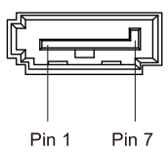
Pin | Pin Name | Signal Type | Signal level
1 | +V5S | GND
2 | SATA_TX1+ | DIFF
3 | SATA_TX1- | DIFF
4 | GND | GND
5 | SATA_RX1- | DIFF
6 | SATA_RX1+ | DIFF
7 | GND | GND

(CN9) Battery
Pin | Pin Name | Signal Type | Signal level
1 | +3.3V | PWR | 3.3V
2 | GND | GND

(CN11) USB3.2 Gen 1 Port 1, Port 2
Pin | Pin Name | Signal Type | Signal level
1 | +5VSB | PWR | +5V
2 | USB0_D- | DIFF
3 | USB0_D+ | DIFF
4 | GND | GND
5 | USB0_SSRX− | DIFF
6 | USB0_SSRX+ | DIFF
7 | GND | GND
8 | USB0_SSTX− | DIFF
9 | USB0_SSTX+ | DIFF
10 | +5VSB | PWR | +5V
11 | USB1_D- | DIFF
12 | USB1_D+ | DIFF
13 | GND | GND
14 | USB1_SSRX− | DIFF
15 | USB1_SSRX+ | DIFF
16 | GND | GND
17 | USB1_SSTX− | DIFF
18 | USB1_SSTX+ | DIFF

(CN12) +5V Output for SATA HDD
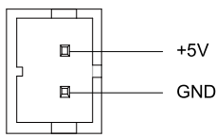
Pin | Pin Name | Signal Type | Signal level
1 | +5V | PWR | +5V
2 | GND | GND

(CN13) HDMI Port
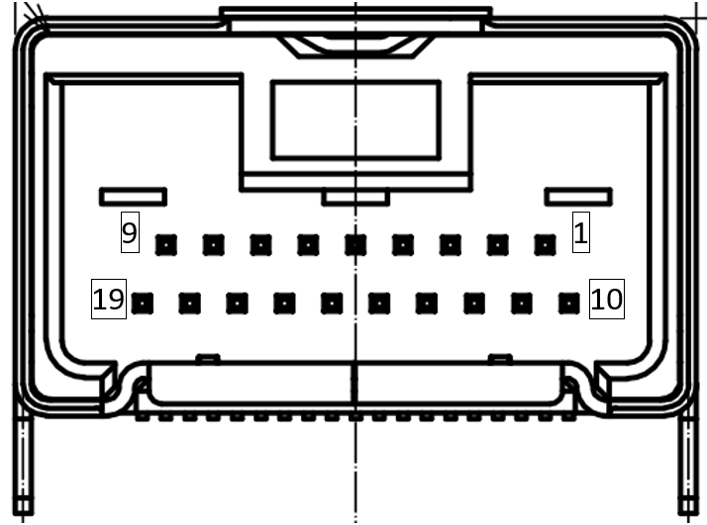
Pin | Pin Name | Signal Type | Signal level
1 | GND | GND
2 | TMDS_DAT1+ | DIFF
3 | TMDS_DAT1- | DIFF
4 | GND | GND
5 | TMDS_CLK+ | DIFF
6 | TMDS_CLK- | DIFF
7 | NC
8 | DDC_DATA | I/O | +5V
9 | +5V | PWR | +5V
10 | TMDS_DAT2+ | DIFF
11 | TMDS_DAT2- | DIFF
12 | GND | GND
13 | TMDS_DAT0+ | DIFF
14 | TMDS_DAT0- | DIFF
15 | GND | GND
16 | NC
17 | DDC_CLK | I/O | +5V
18 | GND | GND
19 | HPLG_DETECT | IN

(CN14) External +12V Input
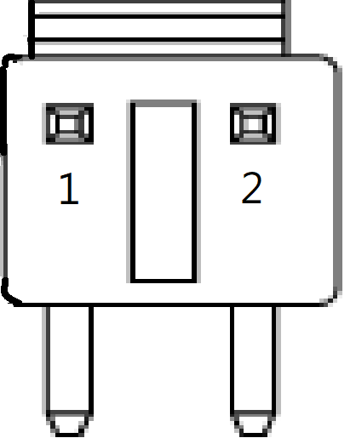
Pin | Pin Name | Signal Type | Signal level
1 | +12V | PWR | +12V
2 | GND | GND

(CN15) DDR3L SO-DIMM Slot
Standard specifications

(CN16) LVDS Port
Note1: LVDS LCD_PWR can be set to +3.3V or +5V by JP2
Note2: The max. driving current is 2A.
Pin | Pin Name | Signal Type | Signal level
1 | BKL_ENABLE | OUT
2 | BKL_CONTROL | OUT
3 | LCD_PWR | PWR | +3.3V/+5V
4 | GND | GND
5 | LVDS_A_CLK- | DIFF
6 | LVDS_A_CLK+ | DIFF
7 | LCD_PWR | PWR | +3.3V/+5V
8 | GND | GND
9 | LVDS_DA0- | DIFF
10 | LVDS_DA0+ | DIFF
11 | LVDS_DA1- | DIFF
12 | LVDS_DA1+ | DIFF
13 | LVDS_DA2- | DIFF
14 | LVDS_DA2+ | DIFF
15 | LVDS_DA3- | DIFF
16 | LVDS_DA3+ | DIFF
17 | DDC_DATA | I/O | +3.3V
18 | DDC_CLK | I/O | +3.3V
19 | LVDS_DB0- | DIFF
20 | LVDS_DB0+ | DIFF
21 | LVDS_DB1- | DIFF
22 | LVDS_DB1+ | DIFF
23 | LVDS_DB2- | DIFF
24 | LVDS_DB2+ | DIFF
25 | LVDS_DB3- | DIFF
26 | LVDS_DB3+ | DIFF
27 | LCD_PWR | PWR | +3.3V/+5V
28 | GND | GND
29 | LVDS_B_CLK- | DIFF
30 | LVDS_B_CLK+ | DIFF

(CN17) COM Port 1, Port 2 and Line-Out Connector
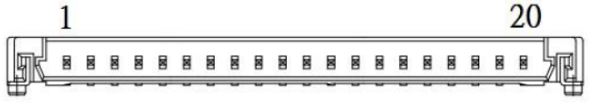
Pin | Pin Name | Signal Type | Signal level
1 | SPI_SO | IN
2 | GND | IN
3 | SPI_CLK | IN
4 | RTSB | OUT | ±9V
5 | TXB | OUT | ±9V
6 | CTSB | IN
7 | DTRB | OUT | ±9V
8 | RIB/+5V/+12V | IN/ PWR | +5V/+12V
9 | DCDA | IN
10 | DSRA | IN
11 | RXA | IN
12 | RTSA | OUT | ±9V
13 | TXA | OUT | ±9V
14 | CTSA | IN
15 | DTRA | OUT | ±9V
16 | RIA | IN
17 | GND | GND
18 | AGND | GND
19 | LOUT_R | I/O
20 | LOUT_L | I/O

COM Port2 RS-485
Pin | Pin Name | Signal Type | Signal level
1 | RS485_D- | I/O | ±5V
2 | NC
3 | RS485_D+ | I/O | ±5V
4 | NC
5 | NC
6 | NC
7 | NC
8 | NC/+5V/+12V | PWR | +5V/+12V
17 | GND | GND

COM Port2 RS-422
Pin | Pin Name | Signal Type | Signal level
1 | ESPI_IO0 | IN/OUT | +1.8V
2 | ESPI_IO1 | IN/OUT | +1.8V
3 | ESPI_IO2 | IN/OUT | +1.8V
4 | ESPI_IO3 | IN/OUT | +1.8V
5 | +V3.3S | PWR | +3.3V
6 | ESPI_CS | Signal
7 | ESPI_RESET# | OUT | +1.8V
8 | GND | GND
17 | ESPI_CLK | OUT | 1.8V
Note1: COM2 RS-232/422/485 can be set by BIOS setting. Default is RS-232.
Note2: COM2 RI/+5V/+12V function can be set by BOM (R248-RI/ R256-+12V/
R250-+5V)

(CN18) LPC Port
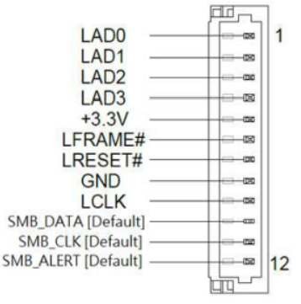
Pin | Pin Name | Signal Type | Signal level
1 | LAD0 | I/O | +3.3V
2 | LAD1 | I/O | +3.3V
3 | LAD2 | I/O | +3.3V
4 | LAD3 | I/O | +3.3V
5 | +3.3V | PWR | +3.3V
6 | LFRAME# | IN
7 | LRESET# | OUT | +3.3V
8 | GND | GND
9 | LCLK | OUT
10 | SMB_DATA [Default]/I2C_DATA | I/O | +3.3V
11 | SMB_CLK [Default]/I2C_CLK | OUT | +3.3V
12 | SMB_ALERT [Default]/INT_SERIRQ | I/O | +3.3V

(CN19) USB2.0 Port 1
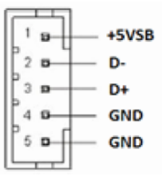
Pin | Pin Name | Signal Type | Signal level
1 | +5VSB | PWR | +5V
2 | USBD5- | DIFF
3 | USBD5+ | DIFF
4 | GND | GND
5 | GND | GND

(CN20) LAN (RJ-45) Port
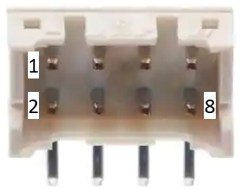

Pin | Pin Name | Signal Type | Signal level
1 | MDI3+ | DIFF
2 | MDI3- | DIFF
3 | MDI2+ | DIFF
4 | MDI2- | DIFF
5 | MDI1+ | DIFF
6 | MDI1- | DIFF
7 | MDI0+ | DIFF
8 | MDI0- | DIFF

(CN21) LAN (RJ-45) LED Port
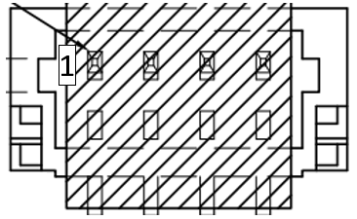
Pin | Pin Name | Signal Type | Signal level
1 | +3.3V | PWR | +3.3V
2 | LAN_1000# | Signal
3 | LAN_ACT | Signal
4 | LAN_100# | Signal

List of mating connectors and cables:

Connector  Label | Function | Mating Connector |  | Available Cable | AAEON Cable P/N
Connector  Label | Function | Vendor | Model no | Available Cable | AAEON Cable P/N
CN1 | Digital IO Port | Molex | 51110-0650 | N/A | N/A
CN2 | LVDS Port Inverter / Backlight Connector | JST | PHR-5 | N/A | N/A
CN3 | Front Panel | Molex | 51110-1050 | Front Panel  Cable | 1701100156
CN7 | BIO connector | HRS | FX18-80S-0.8SV20 | N/A | N/A
CN8 | SATA Port | Molex | 887505318 | SATA Cable | 1709070500
CN9 | Battery | Molex | 51021-0200 | Battery Cable | 175011301C
CN12 | +5V Output for SATA HDD | JST | PHR-2 | SATA power  cable | 1702150155
CN13 | HDMI Port | HRS
CN14 | External +12V Input | JST
CN16 | LVDS Port | ACES | 50247-030H0H0-001 | LVDS Cable | 1704300030
CN17 | COM Port 1, Port 2 and Line-Out Connector | HRS | DF14-20S-1.25C | COM Port  1/2 & line  out cable | 1703200153
CN18 | LPC Port | JST | SHR-12V-S-B | AAEON LPC Cable | 1703120130
CN19 | USB2.0 Port 1 | Molex | 51021-0500 | USB Cable | 1700050207
CN20 | LAN (RJ-45) Port | JST
CN21 | LAN (RJ-45) LED Port | PINREX

